***Documentation***

**Title:** TechCamp Kosovo: Countering Disinformation in the Balkans

**Project description:**

The TechCamp Kosovo project, led by NGO Free Libre Open Source Software Kosova (FLOSSK), aimed to counter disinformation in the Balkans by strengthening public confidence in the free press and democratic institutions. The 18-month project targeted 45 journalists, community leaders, civil society activists, and non-governmental organizations from Kosovo and surrounding regions. The initiative included a three-day workshop held in Peja from November 19-21, 2020, as well as subsequent activities such as sub-awards, an exchange program, and the establishment of a news portal.

**Activities:**Key activities:

* A three-day workshop conducted in Peja in November 2020.
* Exchange programs between participants from different regions.
* Establishment of a news portal aimed at promoting truthful reporting and public education.
* Sub-awards distributed to selected participants to support further projects on countering disinformation.

-

**Photos:**

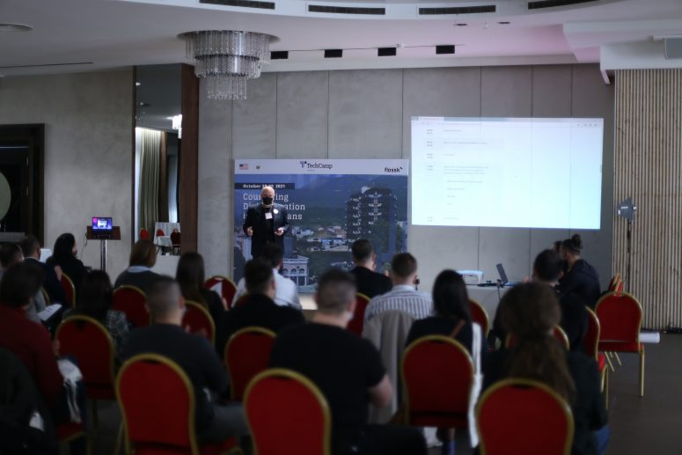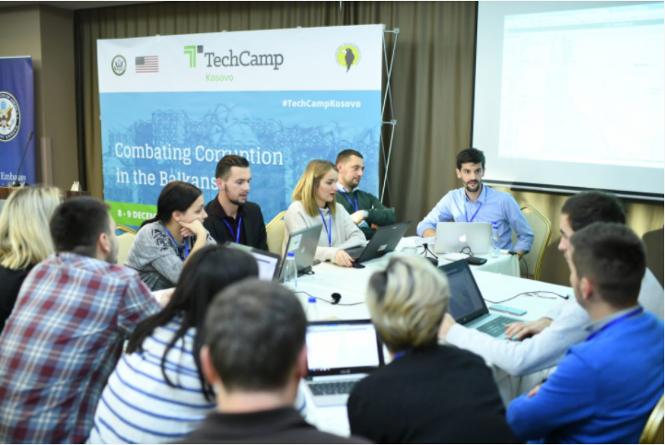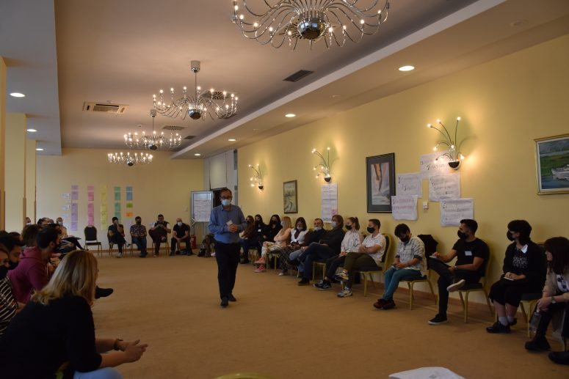

**Beneficiaries:**

The program directly benefited 50 participants from Kosovo, Albania, Bosnia and Herzegovina, Croatia, Montenegro, North Macedonia, Serbia, and Slovenia. This diverse group included journalists, academics, and government spokespersons who focused on tackling disinformation in their respective regions.

**Partners:**

* -Bureau of Educational & Cultural Affairs (ECA)

**Budget:  
€185,000.00**

**Project duration**:

01 July 2020 - 31 December 2021

*This document is FLOSSK intellectual property - Do not share without authorization from FLOSSK.*